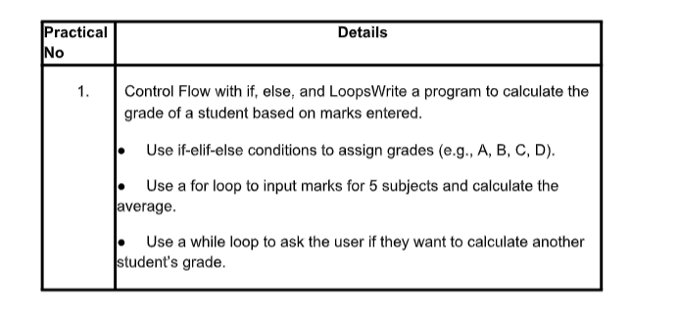

==============================================================================
COMMAND:
"""
Control Flow with if, else, and Loops Write a program to calculate the
grade of a student based on marks entered.
● Use if-elif-else conditions to assign grades (e.g., A, B, C, D).
● Use a for loop to input marks for 5 subjects and calculate the
average.
● Use a while loop to ask the user if they want to calculate another
student’s grade.
"""

while True:
total = 0

print("Enter marks for 5 subjects:-")
for i in range(1, 6):
marks = float(input("Enter marks for subject " + str(i) + ": "))
total += marks

average = total / 5

if average >= 90:
grade = "A"
elif average >= 75:
grade = "B"
elif average >= 60:
grade = "C"
elif average >= 40:
grade = "D"
else:
grade = "F"

print("Average Marks:", average)
print("Grade:", grade)

choice = input("Do you want to calculate another student's grade? (yes/no): ")
if choice.lower() != "yes":
break

OUTPUT:
